Dear Parents,

Below is a chart from the CDC website going over the signs and sympotms of the flu versus a cold. Please be on the look out for the signs or symptoms of the flu and if you see anything developing, please take your child to their pediatrician or doctor to be evaluated. It is critical for early diagnosis for the treatment to be the most effective. If they have a confirmed case of the flu (through objective testing at the doctors) please do let us know.

**What is the difference between a cold and the flu?**

The flu and the common cold are both respiratory illnesses but they are caused by different viruses. Because these two types of illnesses have similar symptoms, it can be difficult to tell the difference between them based on symptoms alone. In general, the flu is worse than the common cold, and symptoms are more common and intense. Colds are usually milder than the flu. People with colds are more likely to have a runny or stuffy nose. Colds generally do not result in serious health problems, such as pneumonia, bacterial infections, or hospitalizations. Flu can have very serious [associated complications(https://www.cdc.gov/flu/about/disease/complications.htm)](https://www.cdc.gov/flu/about/disease/complications.htm).

**How can you tell the difference between a cold and the flu?**

Because colds and flu share many symptoms, it can be difficult (or even impossible) to tell the difference between them based on symptoms alone. Special tests that usually must be done within the first few days of illness can tell if a person has the flu.

**What are the symptoms of the flu versus the symptoms of a cold?**

The [symptoms of flu](https://www.cdc.gov/flu/about/qa/coldflu.htm) can include fever or feeling feverish/chills, cough, sore throat, runny or stuffy nose, muscle or body aches, headaches and fatigue (tiredness). Cold symptoms are usually milder than the symptoms of flu. People with colds are more likely to have a runny or stuffy nose. Colds generally do not result in serious health problems.

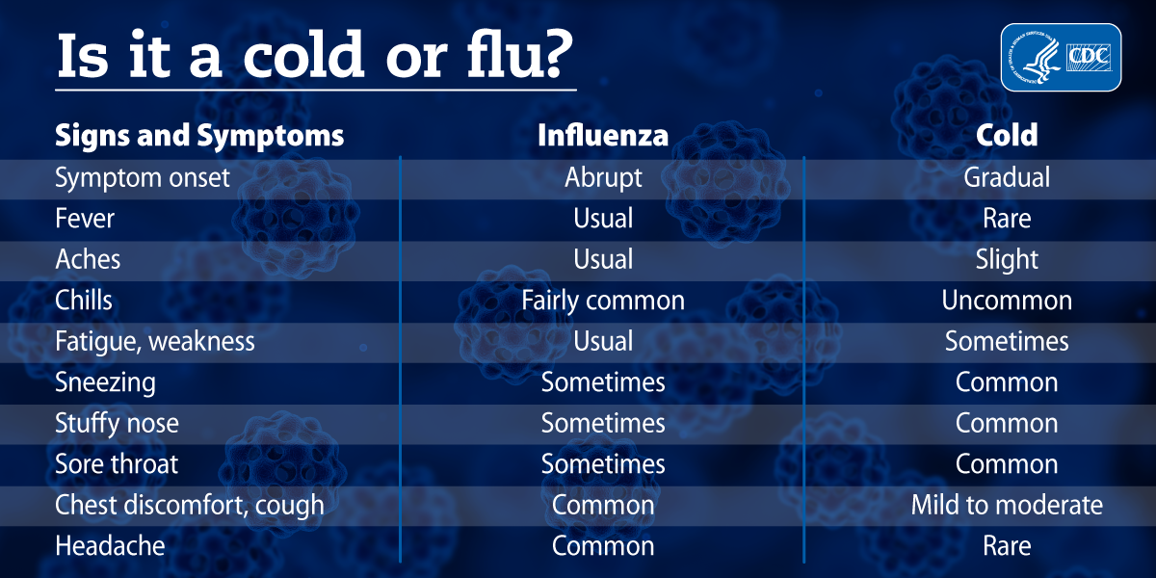

Thank you,

Heather A. Scheid, RN, BSN

School Staff Nurse

mAk0mh[1]FCP Updated Logo

cid:image005.png@01D39E80.D9B66C501380 Valley Forge Rd.   Lansdale, PA 19446

cid:image005.png@01D39E80.D9B66C50215.368.1100   [www.cbschools.org](http://www.cbschools.org/)

Calvary Baptist School inspires students to discover their purpose and to engage their hearts, heads, and hands in service to Christ both locally and globally.