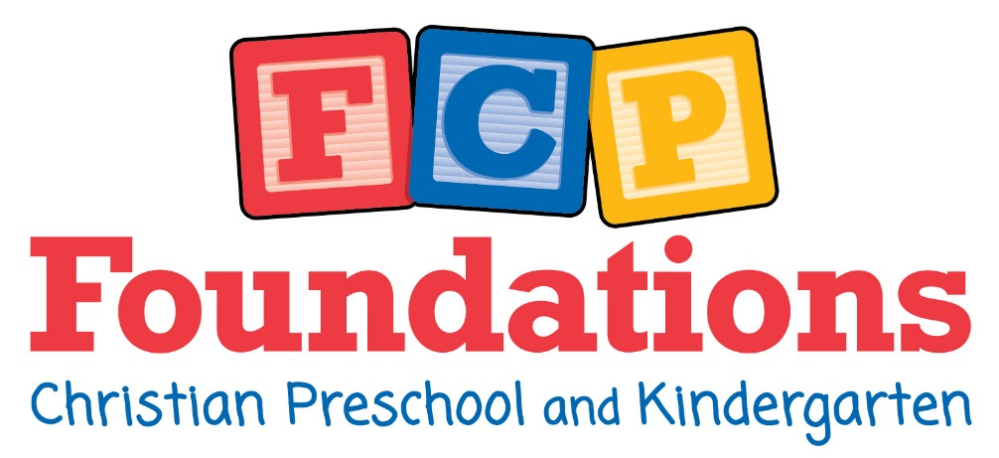
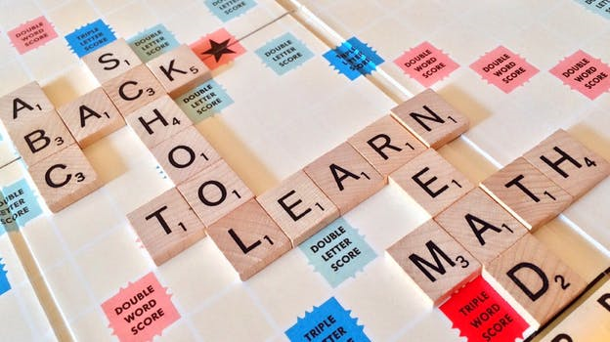

Table of Contents
Overview of Programs………………………………………………………...2
Entrance Requirements……………………………………………………….3
Mission, Purpose, and Goals………………………………………………..3
Daily Schedule…………………………………………………….….…………4-7
Discipline…………………………………………………………..……………..8-9
Illness/Injury…………………………………………………………………..9-10
Dress Code…………………………………………………………………………12
Birthday Celebrations………………………………………………………..13
Snacks/Lunch…………………………………………………………………….13
Rest Time…………………………………………………………………………..14
Field Trips……………………………………………………………….……14-15
Parent Clearances……………………………………………………………..15
Teacher Communication…...………………………………………………16
Arrival/Departure…………………………………………………………16-17
Financial Information……………………………………………………18-19
Absences/Travel……………………………………………………………..…19
Inclement Weather Procedures………………………………………...20

1

Overview of Programs
K3- Our K3 program is designed to ease your child into a school setting. Our K3 teachers mix learning with fun and teach through songs, crafts, activities, and stories. Children will learn to count, recognize numbers, and learn the basic calendar. They will work on one letter a week and do activities that focus on that letter. They also learn basic school manners like sitting in their seats, raising their hand, sharing with friends, and being obedient. K3 has many options- 2 day, 3 day, 5 day, half, and full day.

K4- This program is a great way for children to prepare for Kindergarten! K4 students will work on letters and sounds, and be reading blends and words by the end of the year. They will even be able to read short books! K4 uses a Kindergarten math curriculum so that they are one step ahead. They practice correct letter formation, skills like coloring, tracing, and cutting, and number writing. K4 also has many options- 2 day, 3 day, 5 day, half, and full day.

Kindergarten- Both AM and PM classes are offered with a complete Kindergarten program- phonics based reading program, first grade math curriculum, handwriting, Bible, music, computers, library, and Physical Education
Full Day Kindergarten adds an afternoon of enrichment with fun, hands-on learning! There is extra practice in reading and math, STEM (Science, Technology, Engineering, Math), Geography, Photography, and Art.

2

Entrance Requirements
- Enrollment application and fee
- Birth Certificate (or passport if birth certificate is unavailable)
- Doctor’s physical examination form
- Up to date immunization records
- A pre-admission conference with an administrator if required for admission. You will get to tour the facility, meet teachers, and ask questions. Follow-up forms will be given at this time as well.
- All children must be fully “potty-trained” before they begin school. Diapers and pull-ups are not permitted.
Mission, Purpose, and Goals
Every child needs to develop the essential skills necessary to build a solid educational foundation. Foundations Christian Preschool and Kindergarten students are provided the opportunity to develop a proficiency in reading and math that will set the stage for future learning. Everything we do is designed to build a positive and enjoyable Christian learning environment that will provide students with the tools necessary to help them succeed in school. We are committed to developing the godliness of character and action in the lives of the students entrusted to our care. We teach and encourage the students to practice honesty, kindness, thankfulness, obedience, cooperation, patience, attentiveness, and respect.

3

Sample Daily Schedule- Preschool

Preschool Half-Day Schedule
6:30-8:00 Early child care if needed
8:00-8:30 Pre-classroom activities- puzzles, books, blocks, games, coloring, etc.
8:30-8:45 Pledges, Prayer, Calendar, Weather, Counting, Letters and Sounds, Review, Songs, Shapes
8:45-9:15 Math- K3- numbers, counting, practice K4- Saxon math curriculum (Kindergarten level)
9:15-9:45 Crafts, Science Experiments, Art
9:45-10:00 Snack- parents provide snack for their child
10:00 -10:15 Recess
10:15-10:40 Phonics- Letters, Sounds, Handwriting, Blends, Words
10:40-11:00 Bible lesson- songs, story, verses
11:00-11:10 Pack up for dismissal
11:10-11:30 Dismissal at church entrance

4

Preschool Full-Day Schedule
6:30-8:00 Early child care if needed
8:00-8:30 Pre-classroom activities- puzzles, books, blocks, games, coloring, etc.
8:30-8:45 Pledges, Prayer, Calendar, Weather, Counting, Letters and Sounds, Review, Songs, Shapes
8:45-9:15 Math- K3- numbers, counting, practice K4- Saxon math curriculum (Kindergarten level)
9:15-9:45 Crafts, Science Experiments, Art
9:45-10:00 Snack- parents provide snack for their child
10:00 -10:15 Recess
10:15-10:40 Phonics- Letters, Sounds, Handwriting, Blends, Words
10:40-11:00 Bible lesson- songs, story, verses
11:00-11:10 Pack up for child care
11:15-12:00 Lunch
12:00-12:30 Recess
12:30-1:15 Special Activities- STEM (Science, Technology, Engineering, Math) craft, art project, music time, phonics enrichment, etc.
1:15-1:45 “Down-time”- books, short movie, bathroom break, nap preparations
1:45-2:45 Nap
2:45-3:00 Snack (provided by school)
3:00-6:00 Afternoon child care- toys, playground, gym time, (another snack will be offered at 5:00)

5

Sample Daily Schedule- Kindergarten
Half-Day Schedule- AM Kindergarten
6:30-7:55 Early child care if needed
7:55-8:05 Pre-classroom activities- puzzles, books, coloring, unpack, sharpen pencils, etc.
8:05-8:20 Pledges, calendar, math meeting
8:20-8:30 Handwriting lesson
8:30-9:00 Reading groups
9:00-9:20 Bible lesson
9:20-9:30 Snack- parents provide snack for their child
9:30-10:00 Math lesson and worksheets
10:00-10:15 Recess
10:15-10:45 Phonics lesson and worksheets
10:45-11:00 Math review
11:00-11:15 Pack up, read books, show and tell
11:15-11:30 Dismissal at church entrance

Half-Day Schedule- PM Kindergarten
11:55-12:05 Pre-classroom activities- puzzles, books, coloring, unpack, sharpen pencils, etc.
12:05-12:20 Pledges, calendar, math meeting
12:20-12:30 Handwriting lesson
12:30-1:00 Reading groups
1:00-1:20 Bible lesson
1:20-1:30 Snack- parents provide snack for their child
1:30-2:00 Math lesson and worksheets
2:00-2:15 Recess
2:15-2:45 Phonics lesson and worksheets
2:45-3:00 Math review
3:00-3:15 Pack up, read books, show and tell
3:15-3:30 Dismissal at church entrance

6

Full-Day Schedule-Kindergarten
6:30-7:55 Early child care if needed
7:55-8:05 Pre-classroom activities- puzzles, books, coloring, unpack, sharpen pencils, etc.
8:05-8:20 Pledges, calendar, math meeting
8:20-8:30 Handwriting lesson
8:30-9:00 Reading groups
9:00-9:20 Bible lesson
9:20-9:30 Snack- parents provide snack for their child
9:30-10:00 Math lesson and worksheets
10:00-10:15 Recess
10:15-10:45 Phonics lesson and worksheets
10:45-11:00 Math review
11:00-11:15 Pack up, read books, show and tell
11:15-12:00 Lunch
12:00-12:30 Recess
12:30-2:30 Enrichment Activities- STEM (Science, Technology, Engineering, Math) craft, art project, music time, phonics, geography, photography, sketching, etc.
2:30-3:00 Recess
3:00-3:15 Snack
3:15-3:30 Dismissal for bus or car if leaving now
3:30-6:00 Afternoon child care- toys, playground, gym time (another snack will be offered at 5:00)

7

Discipline
Parents can expect our disciplinary procedures to be loving, kind, consistent, reasonable, and appropriate. The Bible is clear concerning the need for Christian teaching regarding right and wrong behavior, loving correction, and sensible boundaries in order to “Train up a child in the way he should go…”(Proverbs 22:6).
- The teachers will set clear rules and boundaries so that children will learn what is expected of them.
- The teachers will provide positive attention to children who are behaving well, and use positively phrased instruction- “Please walk in the classroom” instead of “Don’t run”.
- The teachers will provide consistent consequences for persistent misbehavior. We will use natural, logical consequences. If a child throws a toy, the toy will be removed and the child will be asked to change activities.
- If needed, a 2, 3, or 4 minute timeout will be used. The child will be taken to a quiet area of the classroom (still in sight of the teacher) and will sit there to calm down and remember the rules and boundaries.

8

- If a child is behaving in an uncontrollable manner and disrupting the classroom, he/she will be taken to the director’s office. Such behaviors include hurting others or having a tantrum that doesn’t resolve with the teacher’s guidance. A parent will be called to pick up the child and a conference with the parents may be scheduled to try to discover and resolve what underlying causes there may be.
- There will be no tolerance for repeated behavior that directs harm towards another child- hitting, spitting, kicking, biting, etc. To do so is grounds for dismissal. A child will never be permitted to inflict harm on a teacher. This also is grounds for dismissal.

9

Illness and Injury
Please do not bring your child to school if he/she has:
- Runny nose with yellow/green discharge
- Nausea or vomiting
- Contagious cough
- Chills
- Skin rash
- Inflamed eyes
- Fever
- Sore throat
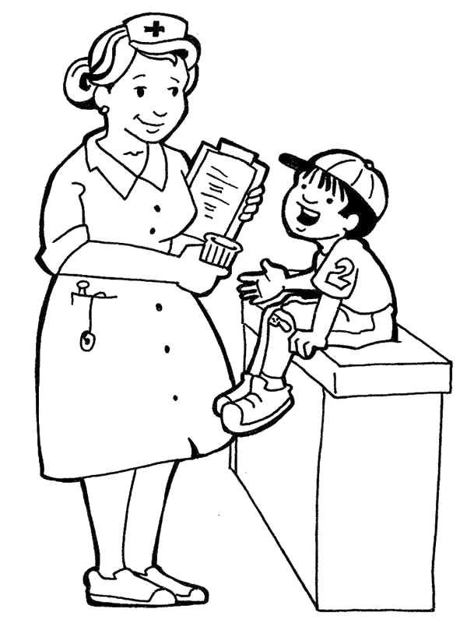
- Enlarged glands
- Diarrhea
- Earache

10

- If your child becomes sick during the course of the day, we will contact you to come and pick the child up as quickly as possible.
- Foundations Christian Preschool and Kindergarten will only administer medicine with a doctor’s note and if the timing of the dose requires it to be during school hours.
- If your child has an inhaler, please send in the inhaler and doctor’s orders for use. Please notify the director as soon as possible so that we can be prepared for emergency!
- If your child has an allergy requiring an epi-pen, please send in the epi-pen and doctor’s orders for use. Please notify the director as soon as possible so that we can be prepared for emergency!
- Your child must be fever/vomiting/diarrhea free for 24 hours before returning to school.
- If your child becomes sick or is injured, the nurse will contact you through a phone call or email depending on the severity of the illness/injury.
- The school will take whatever action it deems necessary for the welfare of the child, which may include administering first aid, calling 911, etc. A parent will always be notified if any of these things occur.

11

Dress Code
Preschool and Kindergarten Boys and Girls:
- Students are asked to dress in a modest, conservative manner that will exemplify Christian values.
- Students should wear comfortable clothing appropriate for playing and doing art projects.
- Clothing that imitates an unacceptable culture or inappropriate video characters is not acceptable. The administration reserves the right to modify the dress code at any time as needed.
- Watches and rings are permitted. Earrings are permitted for girls only.
- Students are not permitted to dress in a way that displays religious beliefs that are out of harmony with the teachings and practices of Calvary Baptist Church.

Preschool and Kindergarten Girls:
- Preschool girls may wear dresses, skirts, slacks, or shorts. No legging styles are to be worn without an appropriate garment over them.
- Kindergarten girls may wear dresses, skirts, or slacks. Shorts are not permitted. No legging styles are permitted.
- Girls’ hair must be a natural color and combed neatly with no extreme styles.
Preschool and Kindergarten Boys:
- Preschool boys may wear long pants or shorts.
- Kindergarten boys are asked to wear long pants and a shirt with a fold-over collar.
- Hair is to be neatly combed, a natural color, closely tapered, and of a reasonable length. No abnormal hair colors or hairstyles that are a distraction in the classroom.

12

Birthday Celebrations
We are always happy to celebrate your child’s birthday with them at school. If you would like to send in a birthday treat, please contact the teachers first. Please be considerate of any allergies in the class as well. The teacher will have a full list of allergies. Children this age don’t usually eat a whole large cupcake, so the smaller ones are usually more manageable with less waste. Other ideas are cookies, rice krispie treats, small individual ice cream, or brownies.
This is in no way required!

Snacks/Lunch

- Morning snacks are provided by the parents for their own child. Please refrain from sending sugary treats, but send food that will help your child learn. Fruit, vegetables, pretzels, crackers, and other healthy snacks are preferred.
- Lunch is provided by the school if your child is signed up for full-day. They do not have to eat the food provided if you would rather pack their lunch. You will receive a menu for each month with the food provided each day. This menu will also be sent in electronic form and will be found on the website.
- Afternoon snacks are provided by the school.
- If your child has any allergies to food, please inform the teacher, director, and nurse right away!

13

Rest Time
Preschool- The 3 and 4 year olds who stay for the afternoon will have a rest time. We provide the cot and clean sheet for each student. Please send in a blanket (labeled is very helpful) for your child to use. You may also send in a small (not bed size) pillow if your child would like one. We will keep the bedding for 2 weeks, and send it home to be washed every other Friday. If there are many colds or sicknesses in the school, we will send the bedding home more often. The children will rest for one hour a day. If they do not sleep, we have them quietly rest on their cots.

Kindergarten- Half Day Kindergarten students have no nap time. Full Day Kindergarten students have no formal nap time, but they do have a quiet time where they can rest quietly at their desks. The teacher might read to them in the beginning of the year, and they can read books on their own as the year progresses.

Field Trips
K3 and K4 visit Merry Mead farm in October. We take a hay ride, learn about Johnny Appleseed, have an apple-cider donut, and pick a pumpkin to take home.

Kindergarten visits the Crayola factory in Easton, PA. They learn how crayons are made and get to participate in many interactive activities.

More information about each of these trips will be provided during the school year. Your tuition will be billed for the amount of the trip if your child is planning on attending that day. Chaperones are needed and appreciated, but you will need to get clearances from the office to attend! It is not

14

acceptable to meet us at the field trip location if you do not have all of the proper clearances. See the section on clearances in this handbook, or call the office for more information.

Parent Clearances
Parents are required to have the proper clearances from the state of Pennsylvania in order to volunteer in the classroom or chaperone field trips.

- The Pennsylvania Access to Criminal History (PATCH) can be done online, and the results are available almost immediately. This clearance is free for volunteers.
- The Child Abuse History Clearance can be completed online. This clearance is free for volunteers.
- The FBI Criminal History Record or Affidavit of Volunteers- this includes fingerprinting and has an approximate $30 fee.
- The Abuse Recognition Online Training can be completed at www.reportabusepa.pitt.edu. This is free to complete.

These clearances may seem excessive, but it is our primary goal to keep our students safe from harm. Call or visit the office to receive the volunteer packet and more information.

15

Teacher Communication
Usually the best and most effective way to communicate with teachers is through email. A teacher’s day is filled with teaching, planning, and caring for the students. Phone calls during teaching hours will not be able to be answered. If you would like to talk to the teacher on the phone, you should email them to set up a time to talk. The same is effective for parent conferences. When dropping off your child, be mindful that the teacher needs to watch, care for, and teach the children at that time and will not have time to talk in excess. Do your best to set up a meeting time with the teacher through email.
Teachers also send communication home through email. Please read these emails as it is the most effective way for the teacher to communicate with the whole class. You may also receive notes home or a phone call if your child has had a challenging day or a day of improvement.

Arrival/Departure
Arrival:
Preschool students need to be walked to their classroom in the morning. They can arrive anywhere between 8:00 and 8:30. We start promptly at 8:00. It is best to let them hang up their own jacket and backpack. Say goodbyes quickly to communicate to them that you trust the teacher and they should too.
Kindergarten students can be dropped off with the elementary students at the main school entrance. Faculty and high school students help by opening doors and assisting. They need to be in the classroom by 8:00 so that they are ready for the 8:05 start time. They also can ride the bus from your home to school. If they ride the morning bus,

16

they will be brought to the gym and taken to their classroom at the appropriate time.

Departure:
Preschool and Kindergarten students who are only staying for half day school can be picked up at the church entrance in the car line. We dismiss students from 11:15-11:30. We dismiss in an orderly fashion by having 6-7 cars pull up to where the teacher is directing traffic. Teachers will walk students to the car and parents should buckle them in. Please make sure that your child is buckled before you leave the parking lot! This is PA state law and is designed to keep your children safe. If you need more time adjusting your child, we kindly ask that you pull into one of the parking spots and complete this task. We do not want to rush you, but also want to make sure that the line continues to move and the parents waiting can pick up their child. Kindergarten students also have the option of riding the bus home if that is set up through your school district. PM Kindergarten students have the bus option as well.

Preschool students getting picked up any time after the 11:15 dismissal need to get picked up in the classroom or playground. You will need to sign them out in the childcare notebook.

Kindergarten students staying for full day can either be picked up in elementary car line at 3:15 or take the afternoon bus home if that has been set up through your school district. Any time after 3:15, they will need to be picked up in the classroom or playground and signed out in the childcare notebook.

17

Financial Information- prices per month
Programs Offered | TUES., THURS. | MON., WED., FRI. | MON. - FRI.
Preschool-½ day  8:00-11:15  Kindergarten-½ day  8:00-11:15 | $205  n/a | $298  n/a | $372  $372
Preschool/Kindergarten full day #1 8:00-3:30 | $428 | $670 | $783
Preschool/Kindergarten full day #2 6:30-3:30 | $489 | $709 | $885
Preschool/Kindergartenfull day #3 8:00- 6:00  Preschool/Kindergartenfull day #4 6:30-6:00 | $517  $578 | $752  $839 | $940  $1,044

**A 10% tuition discount will be given to each additional child—the oldest child pays the full amount. This discount does not apply to childcare. If a preschooler has another sibling(s) in CBS, the 10% discount applies to the preschooler.
**The registration and curriculum fees are non-refundable.
**On non-school days*, students will be charged $6.20 for each hour of attendance in which they are not already enrolled in an Extended Childcare option. This amount is not to exceed $50.00 per day.
**At most two preschool/childcare option changes are permitted per school year at no cost; additional program option changes will be $25.00 per change.
**A fee of $10.20 will be applied to those students who stay for lunch only and are not enrolled in a half-day or full-day option. This covers lunch and childcare from 11:30 a.m. – 12:30 p.m.
**No financial adjustments will be made for any student absences or school cancellations.

18

**Students attending one or more days of any month will owe that month’s full tuition.
**The regular tuition is due for weeks with holidays and is paid over nine months (September through May).
**There will be no childcare provided on days listed as “No Childcare” days on the school calendar.
*Non-school day – includes all days listed on the calendar that Calvary Baptist School is closed. If you desire to have your child attend on a non-school day and he/she is enrolled in the classroom time program only, you will have to sign them up for childcare on non-school days. The current childcare hourly rate will apply. If your child is enrolled in a full-day program, he/she will attend on non-school days during their normal days/hours with no extra fees.

Absences/Travel
If your Kindergarten child is absent for sickness or another reason, please notify the office before 8:30. You can call- 215-368-1100 ext. 102 or email lfinkbeiner@cbs.edu. Parents of preschool students do not need to notify the office when your child is absent, but an email to the teacher is appreciated.

If your family is going away for a couple of days, please notify the office and the teacher beforehand.

If you are traveling out of the country and need your tuition to be put on hold, you will need to obtain a “change” form from the office. Please note that if your child attends even one day of school in a month, you will be billed the full month’s tuition. If you would like school work that your child will miss, please inform the teacher a month in advance if possible to ensure time to collect it.

19

Inclement Weather Procedures

Severe weather or another emergency may require school to be closed for the day or the opening of school to be delayed. For weather closings or delays, CBS will follow the North Penn School District announcements. A decision to close school or delay opening is generally made by 6:00 A.M. and is made for one day at a time. This information is posted on our school website and Facebook page and is relayed to local radio and television stations. If school is in session, the decision to send a child to school is ultimately made by parents and guardians. There are days when school is closed and childcare is still opened on a delayed schedule. You will receive an email about those details as soon as a decision is made.

A Closing Word
We believe that the Christian education made available by our school is based on the foundation laid by parents at home. The Word of God is clear that education begins in the home. It is our desire to work in cooperation with parents who understand their God-given responsibility to raise their children in the discipline and instruction of the Lord.

The families of our students are always welcome to attend the services of Calvary Baptist Church, which sponsors Calvary Baptist School and Foundations Christian Preschool. We invite you to contact us any time you wish to discuss the educational or spiritual needs of your children or family.

20

