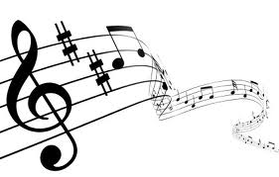
Private
Music
Lessons

2017-2018 School Year

Dear Parents:

We are looking forward to a great year next year in helping your child become a better musician.

If you are interested in private music lessons, please fill out the form below and return to the school office. Current students enrolled in private music lessons here at CBS must also fill out the form below if they wish to continue private lessons. Please fill out one form for each student for each lesson request. We do ask that if you want private music lessons that you commit to the whole year. Some instruments such as guitar will be available only if there is a teacher for that instrument.

Private music lesson prices for the 2017-2018 school year will be $20.00 for a 30-minute lesson and $30.00 for a 45-minute lesson.

For planning purposes it would be helpful if forms are returned to me by email as soon as possible prior to orientation. Thank you for your help in this area.

In Christ,

Mr. Jeff DuBose
jdubose@cbs.edu

Private Music Lesson Registration Form

Student’s Name Grade

Piano lessons are available to students in grades 1-12; other instruments are grades 5-12 only. Instrument instruction depends on availability of teachers.

Circle one:

Piano
Clarinet
Percussion
Violin
Saxophone
Guitar
Cello
Trombone
Baritone
Flute
French horn
Trumpet
Tuba
Voice
(7th-12th grades)

